Professional Institute - CIPFA
CIPFA is the world’s only professional accountancy body to specialise in public services. Our 14,000 members work in both the public and private sectors and are valued for their distinctive specialism as well as technical and leadership skills. We firmly believe working for publicly funded organisations, is challenging, exciting and highly rewarding. It can provide you with the opportunity to give something back and in return you could have a vibrant and fulfilling career.
'CIPFA launched me on the career path that got me to where I am today. The public sector is full of diverse and challenging roles.' Dennis Hone – Chief Executive, Olympic Delivery Authority, London.
Our members work across the globe, often at the most senior levels and are highly influential. Organisations include the Olympic Delivery Authority, the United Nations, the Arts Council England, the IMF, the British Council, the BBC and many, many more.
‘If you are thinking of studying with CIPFA, my advice is go for it! You will gain access to a whole range of places you never usually go to – a huge bonus that cannot be equalled in the private sector.’ Suzanne Flynn - Technical Assistant Adviser, IMF, Washington DC.
‘With CIPFA you are in an ideal position to make a positive difference in a major sector of the economy – with jobs on offer all over the world.’ Gordon Bird, Section Head, United Nations, New York.

The CIPFA Professional Qualification
The CIPFA Professional Qualification is the gold standard financial qualification for government and public services organisations. Designed to equip you with essential accountancy, leadership and strategic skills, become CIPFA qualified in three years or less and reach the top quicker.

Your Pathway to Leadership
As a Chartered Public Finance Accountant (CPFA) you will have the opportunity to work in both the public and private sectors – your qualification can take you anywhere you choose.
With a unique added specialism in the public sector, being CIPFA qualified can help you rise to the top far quicker than you could in the private sector. In addition to the core financial skills you need to work as an accountant, the CIPFA Professional Qualification has leadership, management and strategy training built-in, helping you take on high levels responsibility as you climb your way to the top.

The Modules
There are three stages of assessment to the CIPFA Professional Qualification: Professional Certificate, Professional Diploma and the Strategic stage, with each stage awarding a recognised qualification. Assessment is through exams for each module and a final log of work place experience.
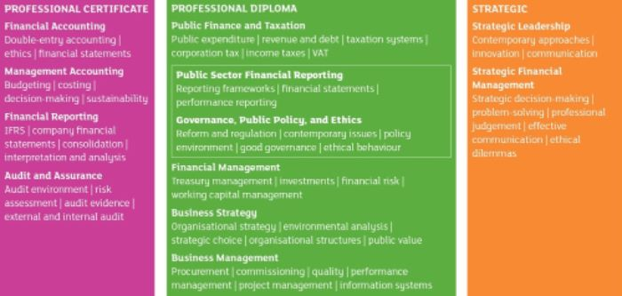
Crucially, it enables you to become qualified in three years of less, during which you will either be in employment or choosing to study outside of employment. There are many employers in search of future finance leaders who are willing and able to help shape the future of the public services, so whether you are a recent graduate or AAT, there is a plethora of trainee schemes available to help you get started on your career in accountancy.
AAT members are eligible for:
- Free exemptions from Financial Accounting and Management Accounting, leaving just ten papers to sit. We are the only accountancy institute to offer FREE exemptions for AAT members!
- A free exemption from the Taxation half module, provided students have successfully completed both Business Tax and Personal Tax as optional AAT modules
- 200 days from the 400 required in the Practical Experience Portfolio (PEP)

Flexible Study
With CIPFA you can study at your own place via classroom tuition, online with CIPFA Live Online or distance learning, choosing the style to suit you.
Exams are held twice a year, in June and December and can be sat at a variety of locations around the country.
For more information contact the CIPFA Student Recruitment team quoting ref: MA13E260OA4
Telephone: 020 7543 5656
E-mail: students@cipfa.org
Website: www.cipfa.org/PQ

Site Map | Accessibility
This is a public site, and non-NHS employees are welcome to access
the information. It should be noted that materials are Crown
copyright, and that the information is targeted at NHS employees.

