FSD Guide - Management of Students & Trainees
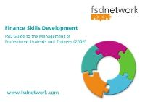
The FSD Guide - Management of Students & Trainees has been produced to support all NHS organisations in the effective management of their NHS finance professional students and trainees, working within the NHS finance function.
In this context, these students and trainees will be undertaking a course of study that will lead them to a recognised accountancy qualification – CIMA, CIPFA, ACCA, ICAEW or AAT. However, the broad principles can be applied to students following other qualifications pathways e.g. Internal Audit, Payroll, etc.
The objective of the guide is to ensure value for money across all elements of the process of supporting professional finance students and trainees – by addressing the issues of learning effectiveness, system efficiency and financial economy. The guide has been written as a self-assessment tool to provide a benchmark of critical success factors that is recognised by the finance function across all organisations in the NHS in England.
It is not intended to reproduce relevant information and guidance that is already easily available and which has been drafted by other organisations.

