Finance Competencies
This new Finance Competency Framework has been developed to reflect the changing needs on the NHS, building on the need for finance teams to become business partners with a broad strategic, commercial and financial focus. The Competence Framework is intended to help every member of the finance team, from band 1 to band 8b. Whether you have ambition to progress, or simply want to do great job where you are, the Framework is intended to help you plan your own development. As a manager it will also help you write job descriptions and person specifications and to recruit, appraise and develop your staff.
The Technical Competencies are supported by a series of appendices, you can download both the overview document and all of the appendices you need by clicking the links below.
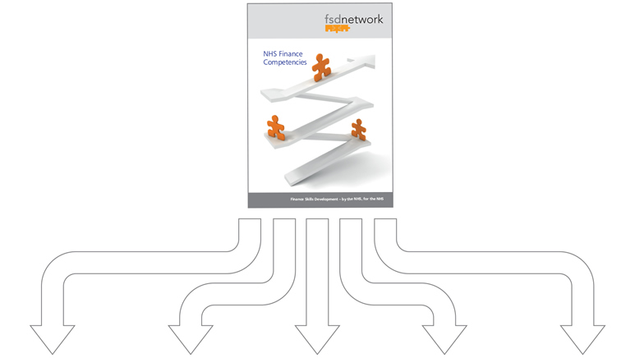
 | 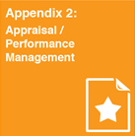 |  | 